1. **System architecture**

Spring container

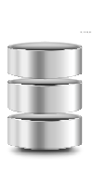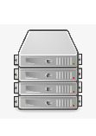

Firebase/PosgreSQL

Tomcat server

Browser

HTTP requests



JPA/Firebase API

Render



HTTP responses

JSP

Picture 1: System architecture

1. **N-tier architecture**



**Browser**

**(Edge/Chrome)**

Client side

Database Access Object

Java.security

Tomcat server

**HTTP**

**server**

Server side

@controller

classes

JSP

Presentation

Layer

**Provide**

**Provide**

Java security

@service

classes

Business

Layer

**Provide**

Spring container

**Support**

**Provide**

Data Access

Layer

Firebase

FireBase CRUD API

JPA

**Support**

HIBERNATE

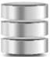

**Database**

**server**

Firebase DB

PosgreSQL